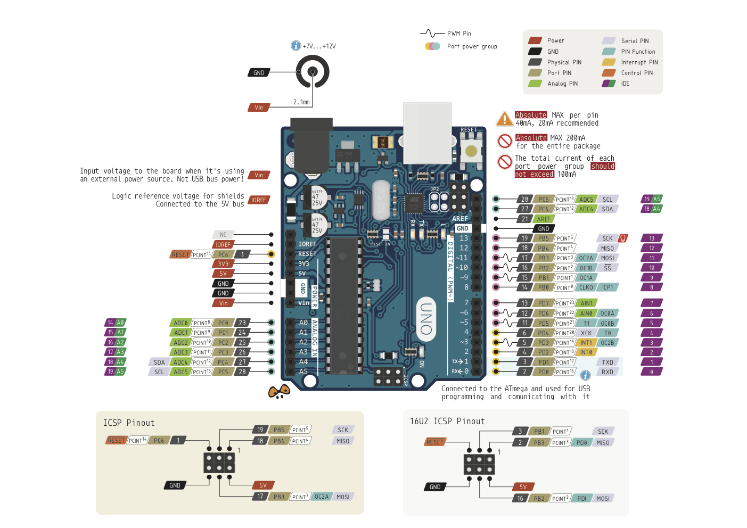

**Binary Counter with Ports – Slide 12**

void setup() {

DDRB = B00000111;

}

void loop() {

PORTB += 1;

delay(1000);

}

**Blink Example – slide 7**

byte pinMask = B00100000;

void setup() {

DDRB = DDRB | pinMask;

}

void loop() {

PORTB = PORTB ^ pinMask;

delay(1000);

}

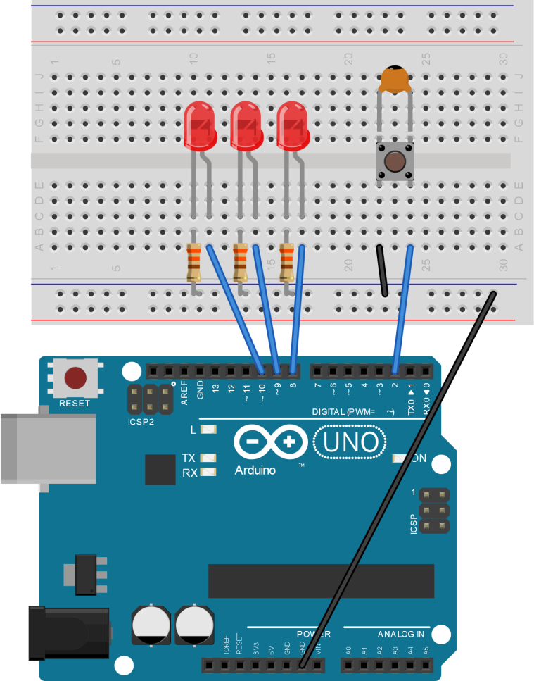

(The only circuit diagram you’ll need for this session – initially without the switch, and then with it later on)

**Binary Counter with EEPROM – Slide 16**

#include <**EEPROM**.h>

const int address = 0;

void setup() {

DDRB = B00000111;

PORTB = **EEPROM**.read(address);

}

void loop() {

delay(1000);

PORTB += 1;

**EEPROM**.write(address, PORTB);

}

**Binary Counter with Interrupt**

**– Slide 21**

#include <**EEPROM**.h>

const int address = 0;

void setup() {

pinMode(2, INPUT_PULLUP);

attachInterrupt(0, buttonPress, FALLING);

DDRB = B00000111;

PORTB = **EEPROM**.read(address);

}

void loop() {

delay(1000);

PORTB += 1;

**EEPROM**.write(address, PORTB);

}

void buttonPress(){

PORTB = 0;

}

**EEPROM Write Example – Slide 15**

#include <**EEPROM**.h>

void setup() {

int i = 0;

byte value;

for( i=0; i<1024; i++){

value = i & 255;

**EEPROM**.write(i, value);

}

}

void loop() {

}

**EEPROM Read Example – Slide 14**

#include <**EEPROM**.h>

void setup() {

**Serial**.begin(9600);

}

void loop() {

int i;

for( i=0; i<1024; i++ ){

**Serial**.print(i);

**Serial**.print(": ");

**Serial**.println(**EEPROM**.read(i));

}

delay(10000);

}